Operating System
Lab-3
Abu Shahid
B20CS003

Part 2- Unix Programming: Client-Math Server Chat Model

Working-
- Server is started which listens to a specified port
- Client is initiated with server IP and port
- After connection is established, it send a simple arithmethic expression which is sent to server through the socket
- Server recieves the expression, evaluates it and sends it back to client which then displays it.

Execution-
- `g++ server1.cpp -o server`
- `./server 5678`
- `g++ client.cpp -o client`
- `./client 127.0.0.1 5678`

Server Model 1
- Server can handle only 1 client
- If any other client attempts to connect to the server, it has to wait indefinitely
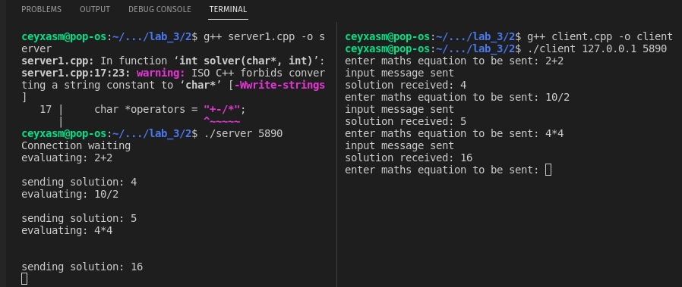

Server Model 2
- Server2 is a multi-process server that forks a new process whenever it recieves a new client request.
- Multiple clients are able to communicate with the server simultaneously.
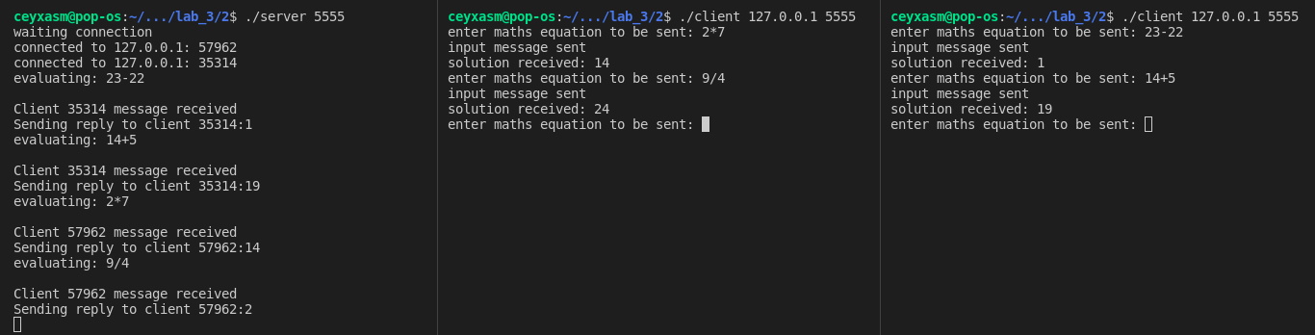

Server Model 3
- In this part, the server is a single process which uses the concept of multithreading that uses select system calls to handle multiple clients concurrently.
- Even if all the all the clients disconnet, the server keeps running as it expects clients to connect.
